Software Requirements Specification

for

Internet Cafe Management System

**CSE 305**

**Prepared by**

**Group Name: Team 5**

|  |  |  |
| --- | --- | --- |
| **Nguyễn Minh Mẫn** | **1831209008** | **man.nguyen.set18@eiu.edu.vn** |
| **Nguyễn Trung Hiếu** | **1531219004** | **hieu.nguyentrung.set15@eiu.edu.vn** |
| **Nguyễn Tiến Đạt** | **1831200047** | **dat.nguyentien.set18@eiu.edu.vn** |
| **Nguyễn Xuân Doanh** | **1831209004** | **doanh.nguyenxuan.set18@eiu.edu.vn** |

|  |  |
| --- | --- |
| **Instructor:** | **Shreya Banerjee** |
| **Course:** |  |
| **Lab Section:** |  |
| **Teaching Assistant:** | **Shreya Banerjee** |
| **Date:** | **November 18, 2021** |

**Contents**

1 Introduction 3

1.1 Document Purpose 3

1.2 Product Scope 4

1.3 Overview Project 4

1.4 Definitions, Acronyms and Abbreviations 4

1.5 Document Conventions 4

1.6 References and Acknowledgments 5

2 Overall Description 6

2.1 Product Overview 6

2.2 Product Functionality 7

2.3 Design and Implementation Constraints 8

2.4 Assumptions and Dependencies 8

3 Specific Requirements 9

3.1 External Interface Requirements 9

3.1.1 User Interfaces 9

3.1.2 Hardware Interfaces 11

3.1.3 Software Interfaces 11

3.2 Functional Requirements 12

3.2.1 The system shall Customer Common Service Manager 12

3.2.2 User Detail 13

3.2.3 Search Users 14

3.2.4 Between Dates Reports 15

3.2.5 Notification homepage 16

3.2.6 Orders 16

3.2.7 Take Orders 17

3.2.8 Category 18

3.2.9 Product 18

3.2.10 Sales Report 19

3.2.11 User 20

3.2.12 System Settings 21

3.3 Use Case Model 22

3.3.1 Use case actor list 22

3.3.2 List of Use Case 23

3.3.3 Use case description 23

3.3.3.1 Ordering operations 23

3.3.3.2 Working on computers 25

3.3.3.3 User Actions 27

3.3.3.4 Menu Operations 31

3.3.3.5 Report 33

4 Other Non-functional Requirements 35

4.1 Performance Requirements 35

4.2 Safety and Security Requirements 35

4.3 Software Quality Attributes 35

4.3.1 Result 35

4.3.2 Advantages and Defect 35

4.3.3 Future work 35

Appendix A – Data Dictionary 36

**Revisions**

|  |  |  |  |
| --- | --- | --- | --- |
| **Version** | **Primary Author(s)** | **Description of Version** | **Date Completed** |
| Draft Type and Number | Full Name | Information about the revision. This table does not need to be filled in whenever a document is touched, only when the version is being upgraded. | 00/00/00 |

# Introduction

Internet Cafe Management Software is a simple PHP/MySQL project that can help a certain coffee shop to manage invoices or customer orders and receipts. This system stores a list of menus or products that a cafe or restaurant serves with their prices, and a list of products sorted by category.

## Document Purpose

The fundamental reason for setting up these archives is to give an overall knowledge into the investigation and necessities of the current framework or circumstance and for deciding the working qualities of the framework. The proposed programming will take care of all the issues they are confronting now. This product is planned in such a way that it will create the bill naturally every request on schedule. So there are very few concerns. This product additionally furnishes the subtleties of every worker in the association, it assists them with following every representative.

This being a website based application is extremely simple to get to. Information and Records are overseen in an incorporated data set. Information is secure and simple to recover, store , and examine, so odds of miscounts and events of blunder are extremely little.

## Product Scope

The Internet coffee will take the customer's order then the cashier or the person or manages the order can check customer service selection. Customers can pay in advance or pay later. To track a customer's order, the cafe will provide a sequence number for each order like the common process of some snack bars, restaurants or coffee shops. If the order is initially saved for later payment, the cashier can navigate to the order page then find the customer's order for the customer to request an invoice. The coffee shop billing system also generates monthly sales reports. The system has a simple calculator for payment transactions, which means the user will only enter the customer's bid amount then the system will calculate the customer's change.

## Overview Project

At present, traders maintain their day-to-day transactions where a waiter has to go to each table and take the order.

During this process, it takes lots of time and customers must wait. Only a single system is used during this process. Cafe owners face a business environment with unique challenges. The tight rope balance between providing the right quality, pricing and ambience, managing with minimal staff and carving a unique identity for one's brand in a crowded market.

## Definitions, Acronyms and Abbreviations

Hypertext Preprocessor(PHP)

Hypertext Markup Language (HTML)

Asynchronous JavaScript and XML(AJAX)

XAMPP is the acronym Cross-Platform (X), Apache (A), MariaDB (M), PHP (P) and Perl (P)

Windows, Apache, MySQL, PHP(WAMP)

LAMP is the acronym for Linux, Apache, MySQL and PHP

Mamp is an acronym for (Macintosh, Apache, MySQL, and PHP)

Internet Explorer 8 (IE8)

Use Case (UC)

JQUERY also simplifies a lot of the complicated things from JavaScript, like AJAX calls and DOM manipulation.

MySQL Database Service is a fully managed database service to deploy cloud-native applications. HeatWave, an integrated, high-performance query accelerator boosts MySQL performance

JavaScript is the Programming Language for the Web

## Document Conventions

Any client of the product framework is the interest group for client documentation created

concerning the product framework. A scope of short record types (e.g., rules, instructional exercises,

habitually posed inquiries) in HyperText Markup Language (HTML) or potentially Portable Document Format (PDF) design should portray the utilization of the product framework.

## References and Acknowledgments

**References**

*[1]. Roger S. Pressman, Bruce R. Maxim (2015). Software Engineering : A Practitioner’s Approach. (Software Engineering). McGraw-Hill Education: New York, NY.*

*[2]. Ian Sommervill (2016). Software Engineering. (Software Engineering). Pearson: Boston.*

*Otto, Mark Jacob Thornton. “Introduction.” Bootstrap, getbootstrap.com/docs/5.0/getting-started/introduction. Accessed 20 Nov. 2021.*

*[3]. Dung, N. T. (2021, November 20). Coding Conventions và các chuẩn viết code trong PHP. Viblo.* [*https://viblo.asia/p/coding-conventions-va-cac-chuan-viet-code-trong-php-naQZRbrGZvx*](https://viblo.asia/p/coding-conventions-va-cac-chuan-viet-code-trong-php-naQZRbrGZvx)

*[4]. Việt P. (2019, June 20). Share 10 giao diện form đăng nhập responsive cực đẹp. BLOG FUVAVI.* [*https://fuvavi.com/share-10-giao-dien-form-dang-nhap-responsive-cuc-dep.html*](https://fuvavi.com/share-10-giao-dien-form-dang-nhap-responsive-cuc-dep.html)

*[5]. w3schools. “PHP Tutorial.” W3schools,* [*www.w3schools.com/php/default.asp. Accessed 20 Nov. 2021*](http://www.w3schools.com/php/default.asp.%20Accessed%2020%20Nov.%202021)*.*

*[6]. W3Schools. “JQuery Tutorial.” W3Schools,* [*www.w3schools.com/jquery/default.asp. Accessed 20 Nov. 2021*](http://www.w3schools.com/jquery/default.asp.%20Accessed%2020%20Nov.%202021)*.*

*[7]. w3schools. “Bootstrap 3, 4 or 5.”*[*www.w3schools.com/bootstrap/bootstrap_ver.asp*](http://www.w3schools.com/bootstrap/bootstrap_ver.asp)*.*

*[8]. W3Schools. “CSS Tutorial.” W3schools,* [*www.w3schools.com/css/default.asp*](http://www.w3schools.com/css/default.asp)*.*

*[9]. W3Schools. “HTML Tutorial.” W3schools,* [*www.w3schools.com/html/default.asp*](http://www.w3schools.com/html/default.asp)*.*

*[10]. W3Schools. “JavaScript Tutorial.” W3schools,* [*www.w3schools.com/js/default.asp*](http://www.w3schools.com/js/default.asp)*.*

*[11]. W3Schools. “SQL Tutorial.” W3schools,* [*www.w3schools.com/sql/default.asp*](http://www.w3schools.com/sql/default.asp)*.*

*[12]. Ullman, Larry. PHP and MySQL for Dynamic Web Sites: Visual QuickPro Guide. 5th ed., Peachpit Press, 2017.*

*[13]. Ulman. PHP & MySQL for Dynamic Web Sites (4th, 12) by Ullman, Larry [Paperback (2011)]. Peachpit, Paperback(2011), 2021.*

*[14].* Bowlin, George. *Php and Mysql for Dynamic Web Sites*. Createspace Independent Pub,2017.

*[15]. Nixon, Robin. Learning PHP, MySQL & JavaScript: With JQuery, CSS & HTML5 (Learning PHP, MYSQL, Javascript, CSS & HTML5). 5th ed., O’Reilly Media, 2018.*

*[16]. Lockhart, Josh. Modern PHP: New Features and Good Practices. 1st ed., O’Reilly Media, 2015.*

*[17]. Weling. PHP and MySQL Web Development (Developer’s Library) by Welling, Luke, Thomson, Laura (2008) Paperback. AdisonWesley Profesional, Paperback(2008), 2021.*

*[19]. Caya, Andrew. Mastering The Faster Web with PHP, MySQL, and JavaScript: Develop State-of-the-Art Web Applications Using the Latest Web Technologies. Packt Publishing, 2018.*

*[20]. Duckett, Jon. PHP & MySQL: Server-Side Web Development. 1st ed., Wiley, 2022.*

*[21]. Froala. “The Next Generation WYSIWYG HTML Editor.” Froala, 17 Nov. 2021, froala.com/wysiwyg-editor.*

*[22]. w3schools. “JSON Introduction.” W3schools, www.w3schools.com/js/js_json_intro.asp.*

*[23]. Jobsen, Bass. Sass and Compass Designer’s Cookbook. Packt Publishing, 2016.*

*[24]. Miguel, Fernando. Magento 2 Development Essentials. Packt Publishing, 2016.*

*[25]. Fontawesome. “Icon for Website.” Fontawesome, fontawesome.com.*

**Acknowledgement**

On the occasion of presenting this project report, we wish to express our deep and profound feelings of gratitude to a number of persons who have contributed to the completion of this project.

The first word we would like to express our deepest appreciation to Mrs. Shreya Banerjee for supporting us in completing this report.

We would like to thank EIU for providing the facilities and learning materials for my reference to carry out the topics. Because we still lack a lot of experience, we still have many mistakes in the practice process. We hope you can share your experience to improve our skills.

During the implementation process due to limited knowledge as well as short time, mistakes are unwanted and we look forward to receiving your comments and feedback.

We sincerely thank you!

# Overall Description

## Product Overview

The study revealed us that there are no fixed limits and hence we had to choose PHP which is the preeminent language of the database management where in any limit can be fed in as specified by the user and accordingly the processes are kept under control.

As this is generic software it can be used by a wide variety of websites (managers to customers) to automate the process of manually maintaining the records related to the subject of maintaining the transaction flows. Coffee shop management systems are important for Coffee Shops.

This software helps the owners of Coffee shops to maintain day-to-day transactions on the computer.

## Product Functionality

**The included Customer common Service Manager application functions :**

* Users
* Admin
* Guest

**Features of the project:**

* **Dashboard** : In this section the administrator can see at a glance the total number of computers and the total number of users arriving in the network cafe.
* **Computer** : In this section, admin can manage computers (add/update).
* **Users** : In this section, admin can add new users, update timeouts, prices and comments, and view details about old users.
* **Search** : In this section, admin can search user based on entry id.
* **Report** : In this section admin can see the number of users coming to the cafe during specific periods.
* **Profile** : In this section admin can update his profile.
* **Change Password** : In this section, admin can change his password
* **Logout**: Through this button, admin can log out.

The included Internet Cafe Billing System application functions include:

**Modules include:**

* Admin
* Staff

**Features of the project:**

* Login page
* The page where the system administrator or user submits their system credentials to access the cafe payment system data and functions.
* The homepage informs all users
* The page where the system user will be redirected by default when logging into the system.
* Category page
* The page where the admin manages the menu list or product category.
* Order page
* The page where the cashier, admin or user will encode a customer order.
* The page where the list of orders is listed and managed.
* Sales Report Page
* The page displays and is ready to print monthly sales reports.
* User page
* The system administration page manages the list of users of the cafe billing system.

## Design and Implementation Constraints

* The information of all users, receipt and check out must be stored in a database that is accessible by the website.
* MySQL Server will be used as SQL engine and database.
* The Coffee Billing System is running as suggested by management.
* Users may access from any computer that has Internet browsing capabilities and an Internet connection.
* Users must have their correct usernames and ID to enter into their online accounts and do actions.

## Assumptions and Dependencies

* The product needs the following third party products.
* MySQL server to store the database.
* PHP to develop the Product.

# Specific Requirements

## External Interface Requirements

### User Interfaces

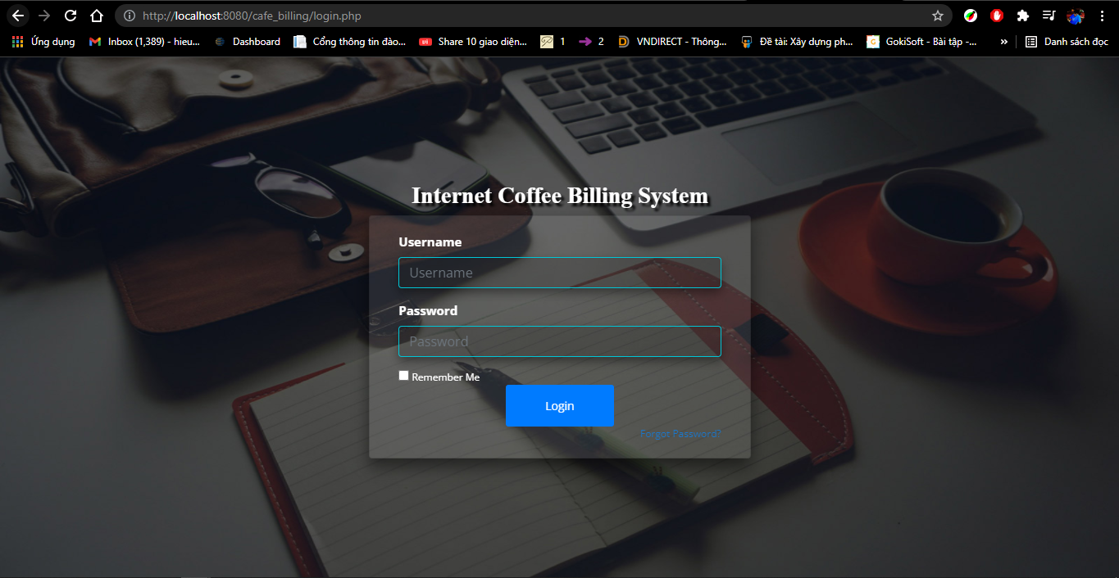Currently we do not have a server to link to the SQL data. So we used XAMPP to create an emulator server on the laptop with the link set to http://localhost:8080/ccms/ and http://localhost:8080/cafe_billing/login.php.

This is login interface CCSM and Billing as shown in the figures :

This is Dashboard interface CCSM :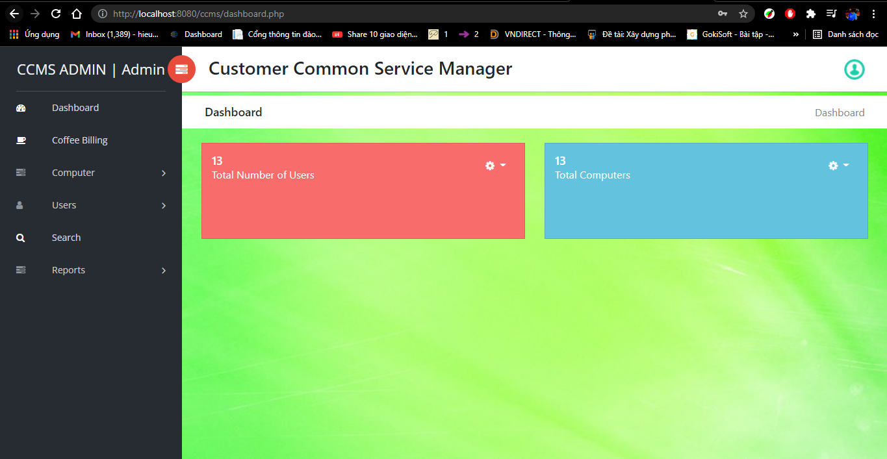

This is notification interface CCSM :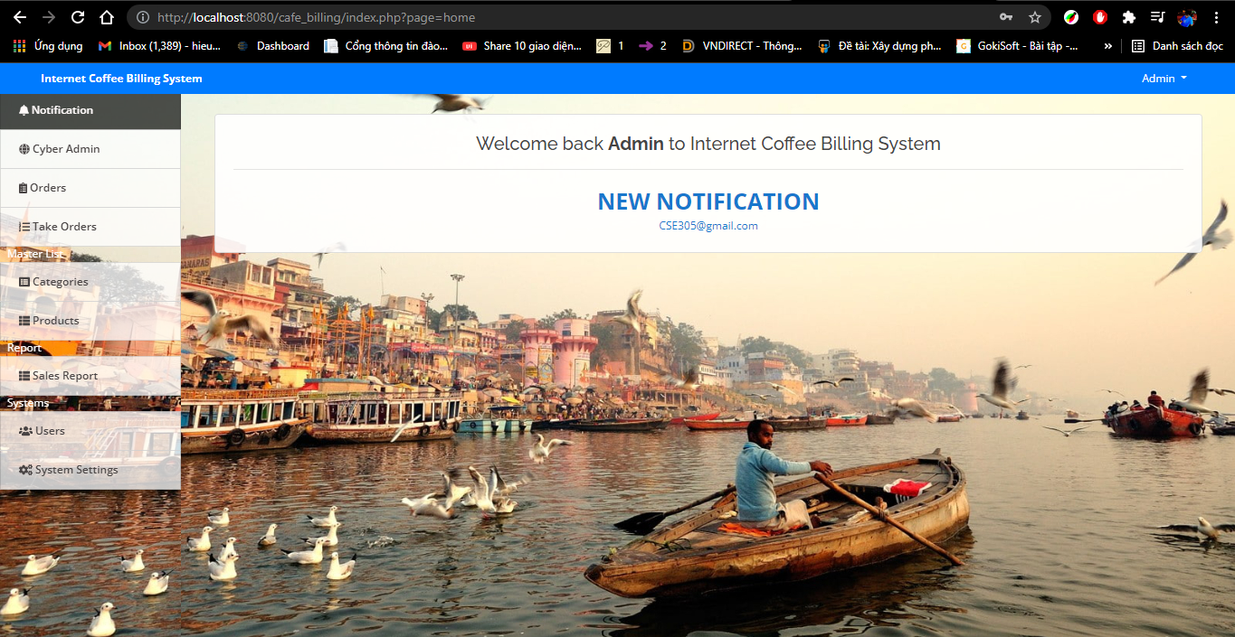

### Hardware Interfaces

Here we would like to analyze the effect of each component to build the server.

Hardware Requirement:

➢ Processor Minimum Intel® Core™ i3

➢ Processor Speed 3.00 Up to 3.90GHz

➢ Hard Disk Min 128GB SSD

➢ Main Memory 8 Gb Ram

➢ Display Type SVGA colour monitor

### Software Interfaces

First, set up any local web server that runs PHP scripts.

Open the web server database and create a new database named cafe_billing_db and ccmsdb.

Import the SQL file located in the source code's database directory.

Copy and paste the source code to the location where your local web server accesses your local projects. With XAMPP the archive for connecting to the MySQL database is located at 'C:\xampp\htdocs'

The connection port is 443.8080 and the MySQL port is 3306, as shown below figure: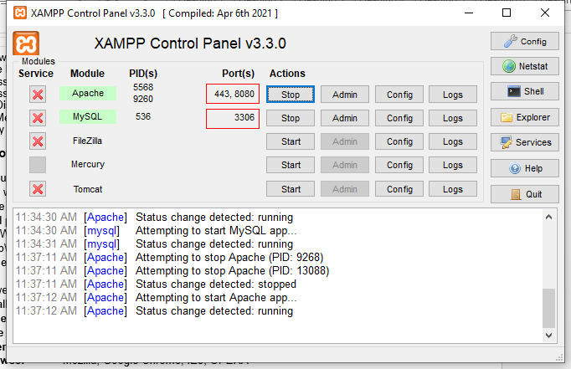

Open a web browser and browse the project.

[Example: <http://localhost:8080/ccms/>] , [<http://localhost:8080/cafe_billing/login.php>].

**Language Used** PHP5.6, PHP7.x

**Database** MySQL 8.0

**User Interface** Design HTML, AJAX,JQUERY,JAVASCRIPT

**Web Browser** Mozilla, Google Chrome, IE8, OPERA

**Software** XAMPP / Wamp / Mamp/ Lamp (anyone)

## Functional Requirements

This program is divided into 3 main accounts: Admin, Employee and Guest. Admin has the function to edit, check and change everything in the application, Employees can pay bills to create accounts for customers and report information during the day. On the Guest side, only accounts are 90 mhbuallowed to use internet services at Coffee. Below we will describe the functions in detail

### The system shall Customer Common Service Manager

In this section we add computer information with: Name, Location, IP address :

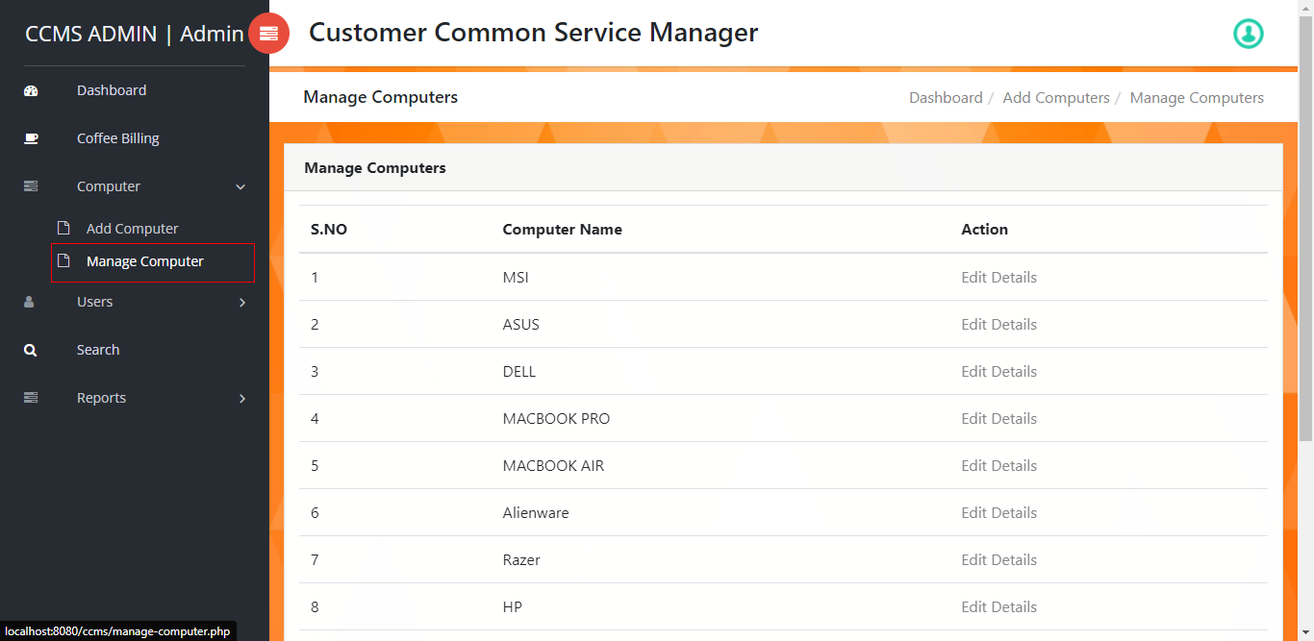The management computer will show a list of computers currently in the shop:

### User Detail

At user details, three users will have Add user, New User Manager and Old User Manager. Adding a user creates an account for the user:

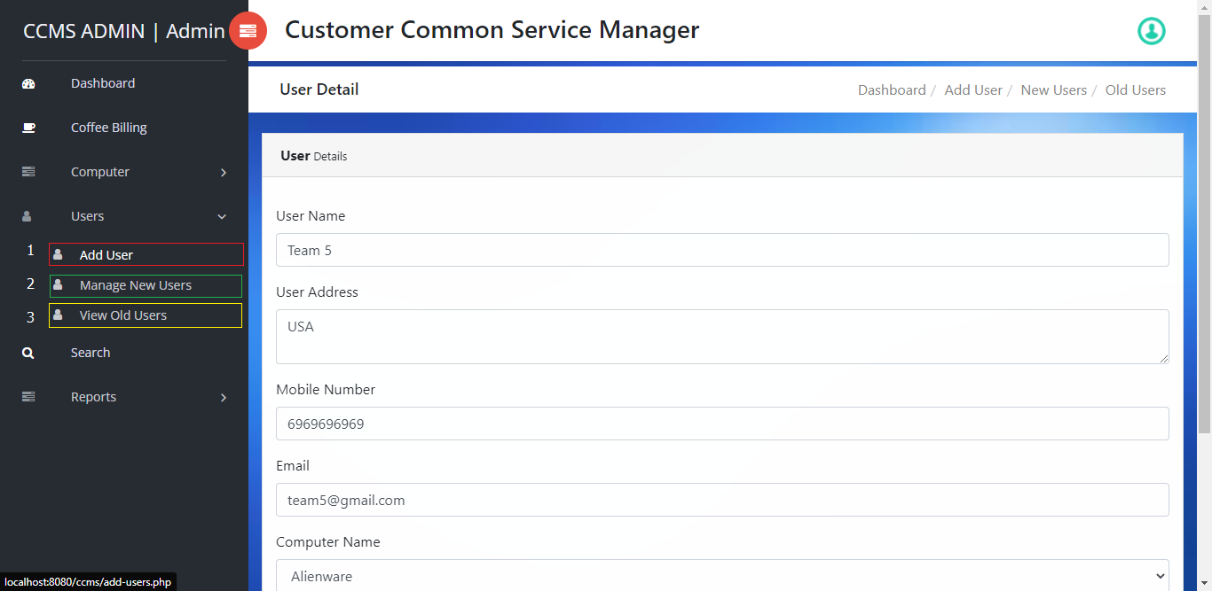

A New user management shows new users who have created an account and are in the shop: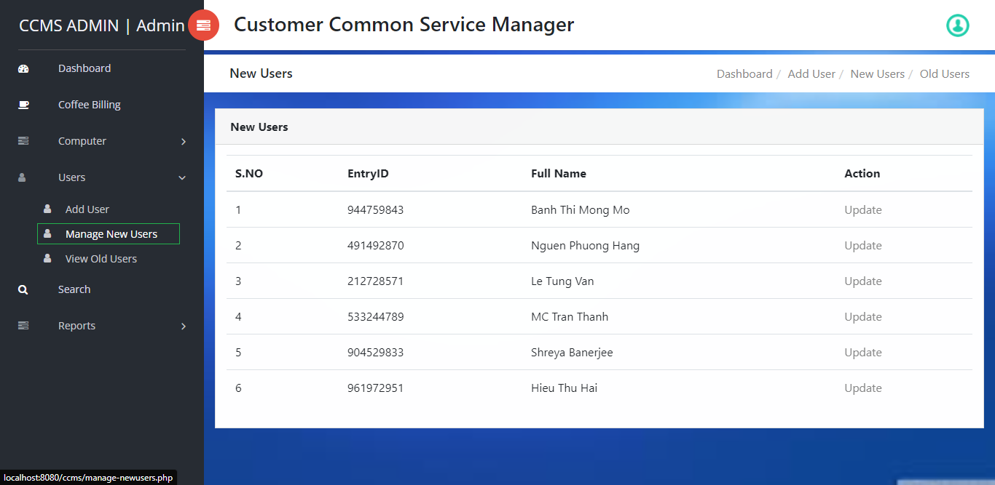

View old users will show a list of checked out guests: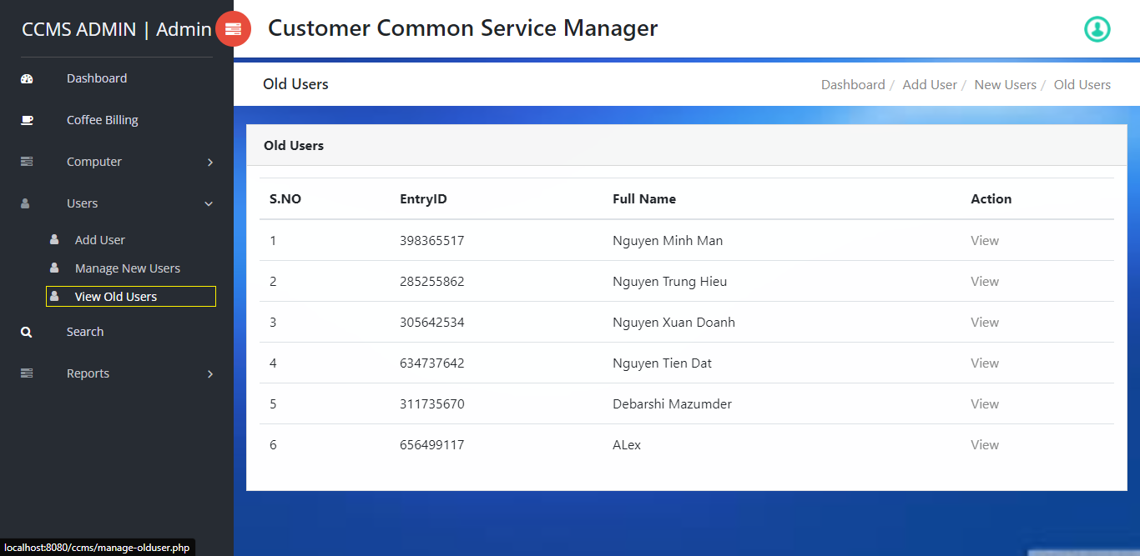

### Search Users

User search, here we can find information quickly by pre-set customer ID :

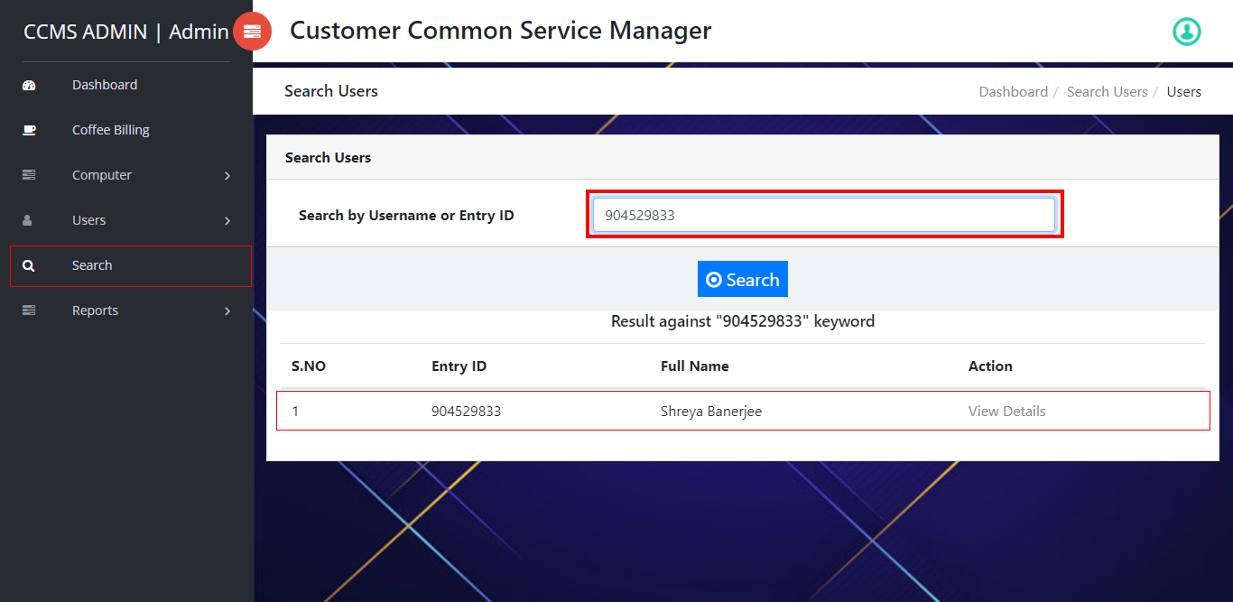

### Between Dates Reports

Dates report, we report the list of customers who have used the internet at the shop daily, weekly or monthly. 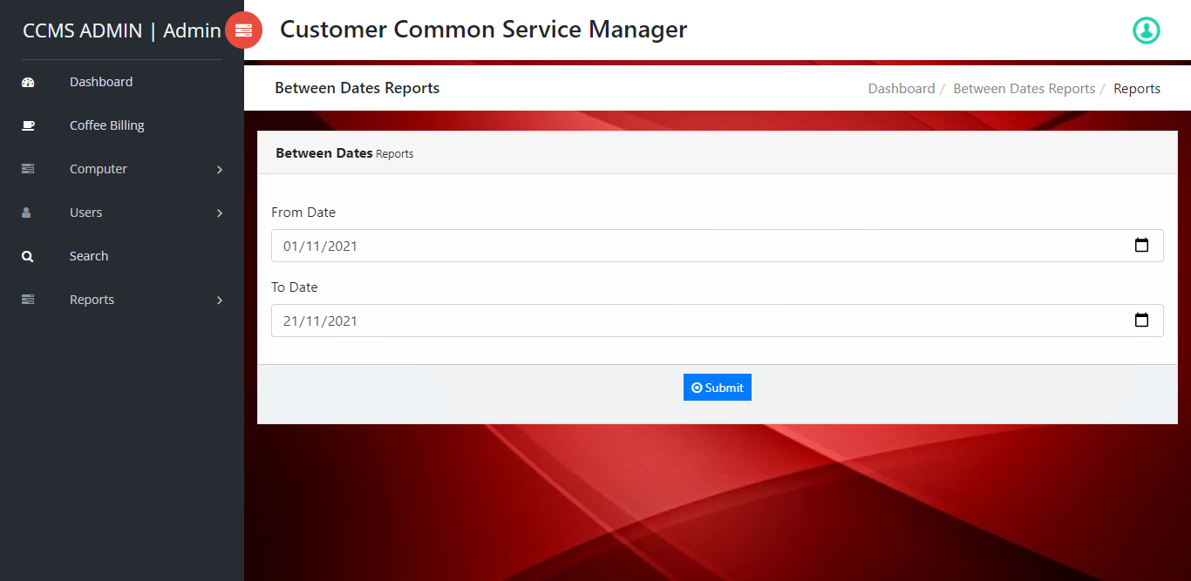

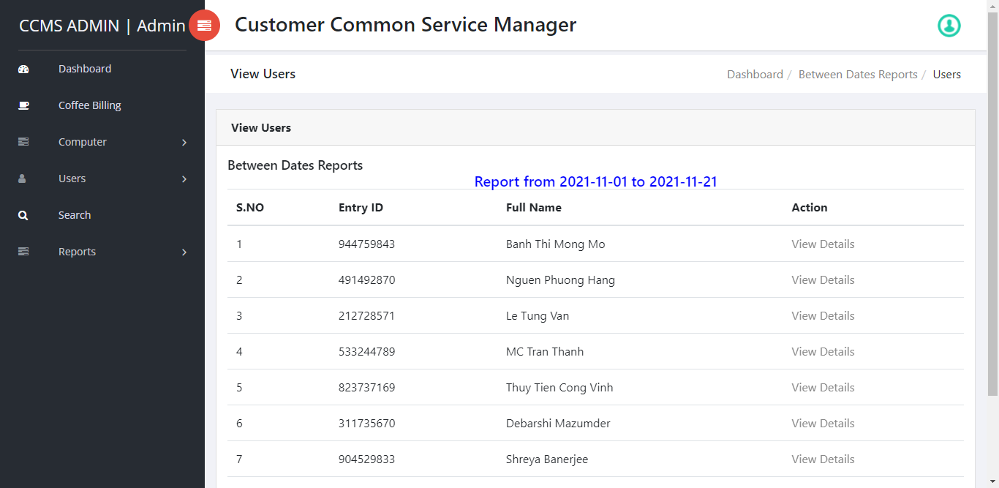

### Notification homepage

This manager or Boss will be alerted with the information of the coffee shop to everyone when using the website.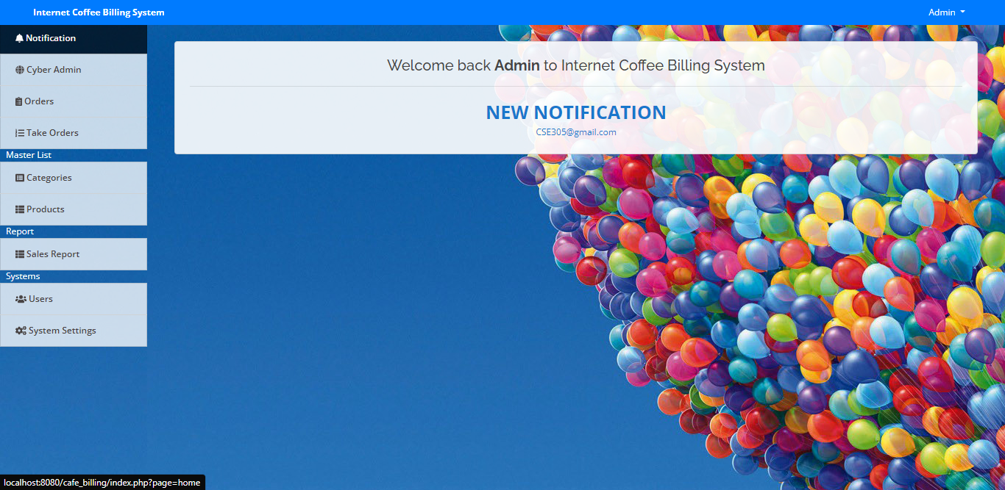

### Orders

The order is Cashier can check, pay and delete the payment invoice.

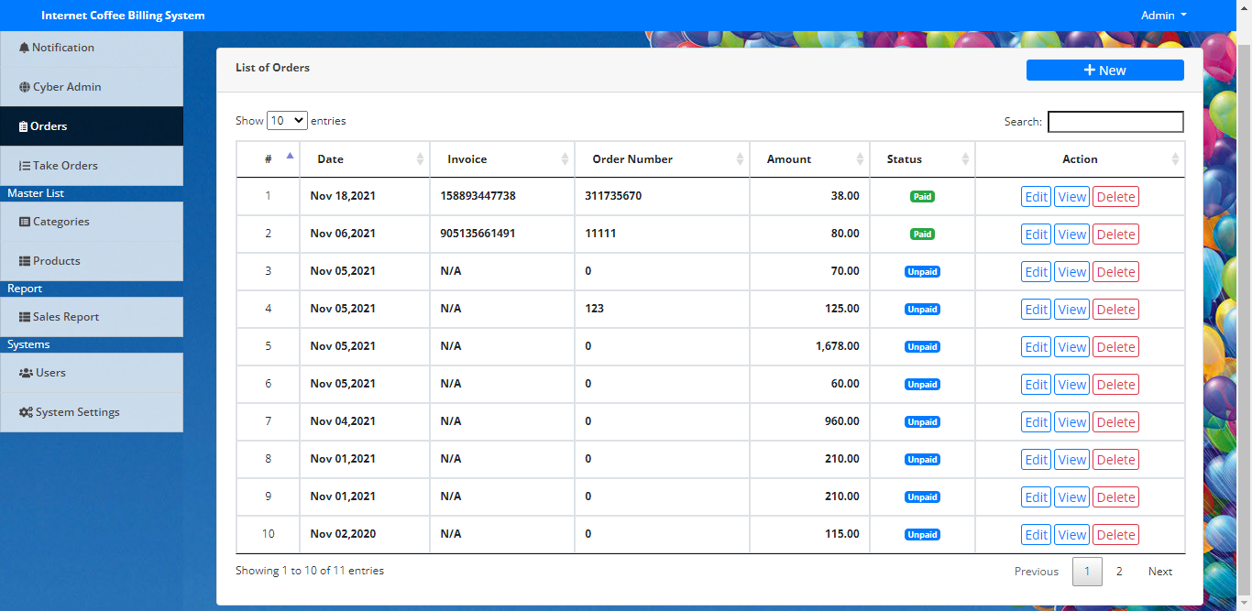

### Take Orders

Receiving orders Cashier or staff can choose the service that customers request at the shop. Can pay in advance or pay later. There is a function to receive amount tendered to return change: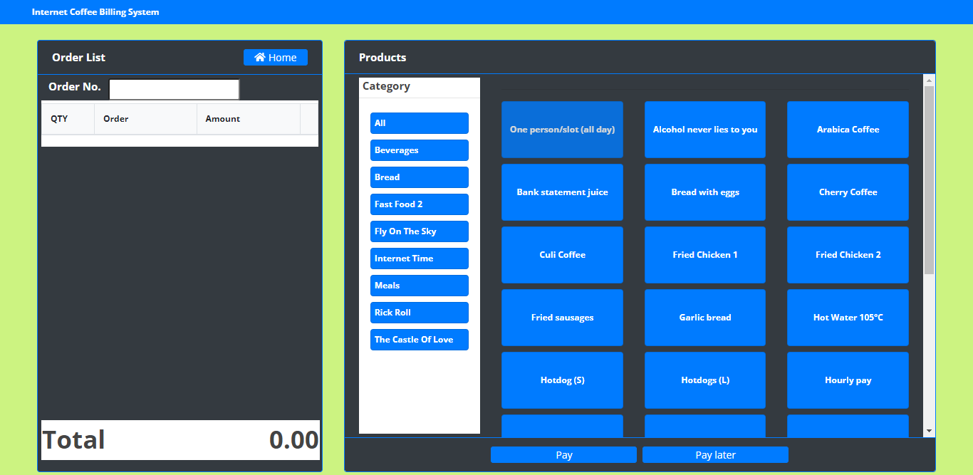

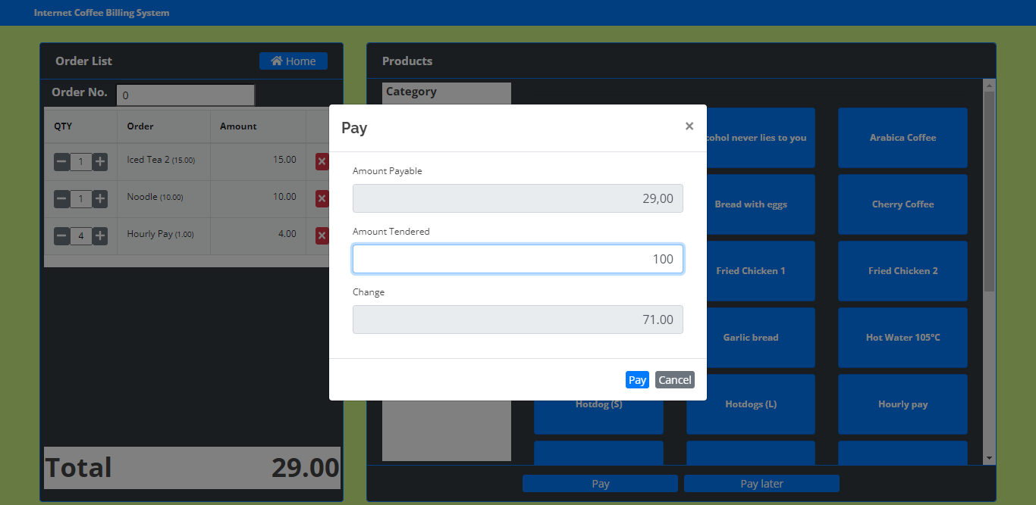

### Category

In this section we can create, update, and categorize services for Take orders:

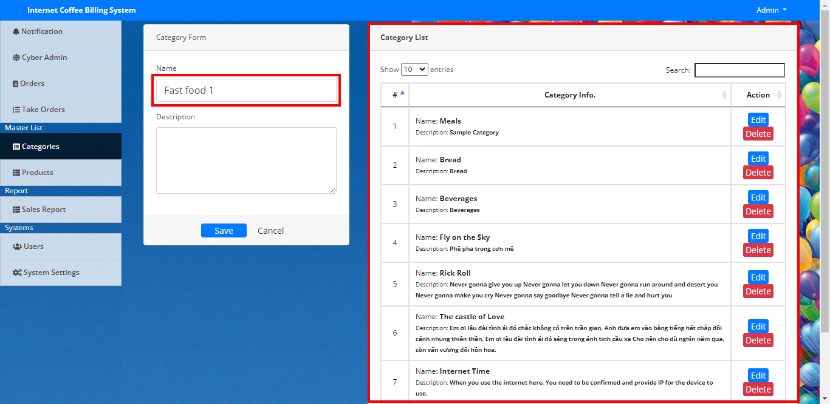

### Product

At product we can add dishes and services for Category

### Sales Report

In the Figure Sales report will be based on the month so that the report is printed, the order list will be updated in this every time the customer makes payment.

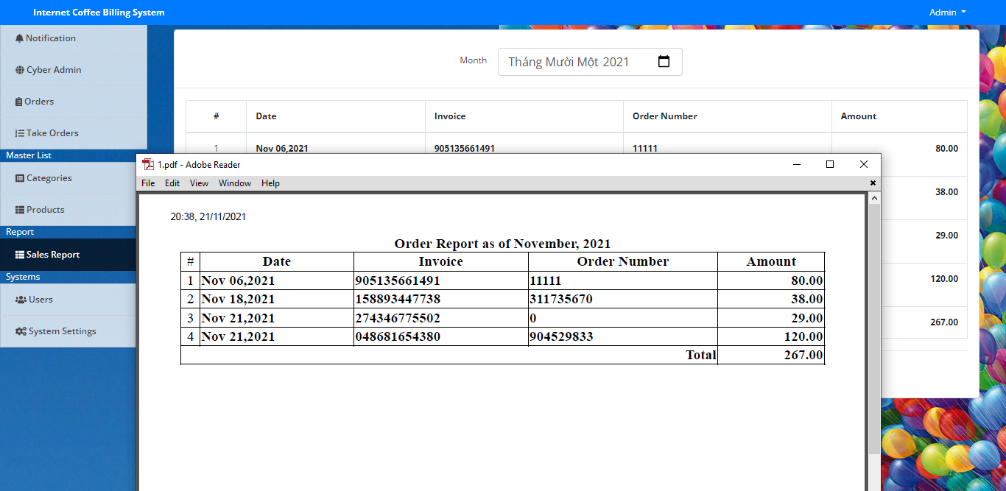

### User

Users helps managers to add, check or edit custom accounts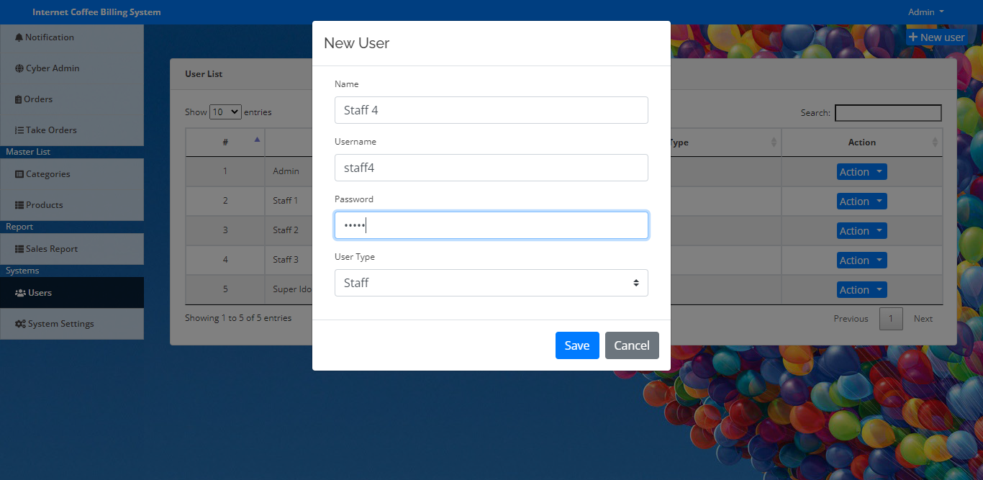

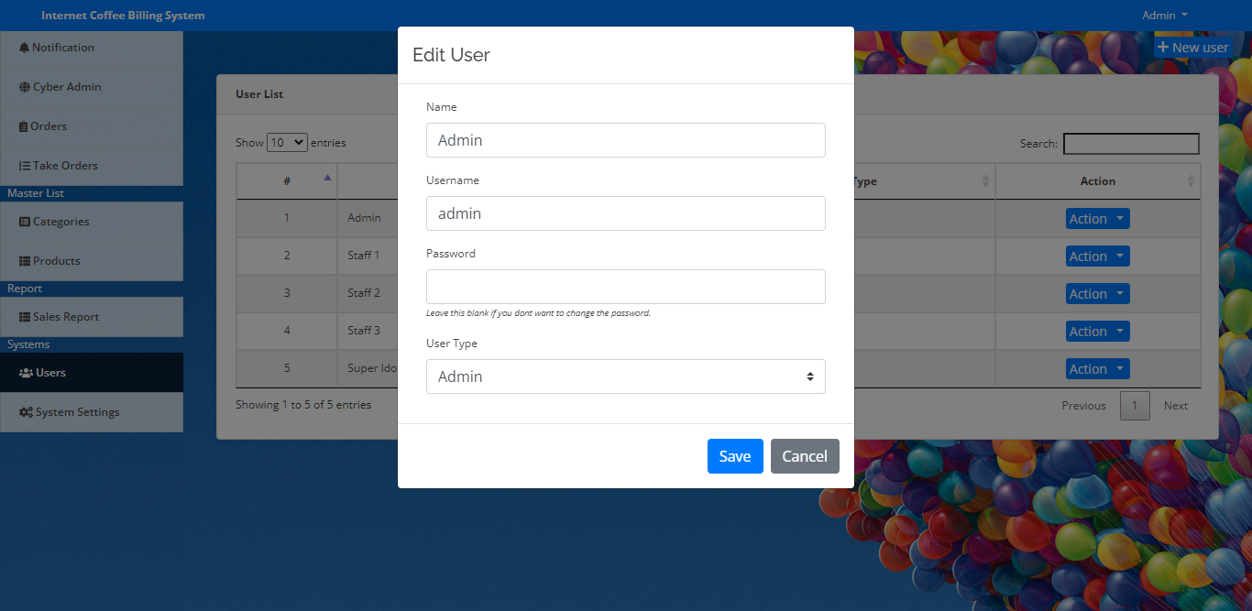

### System Settings

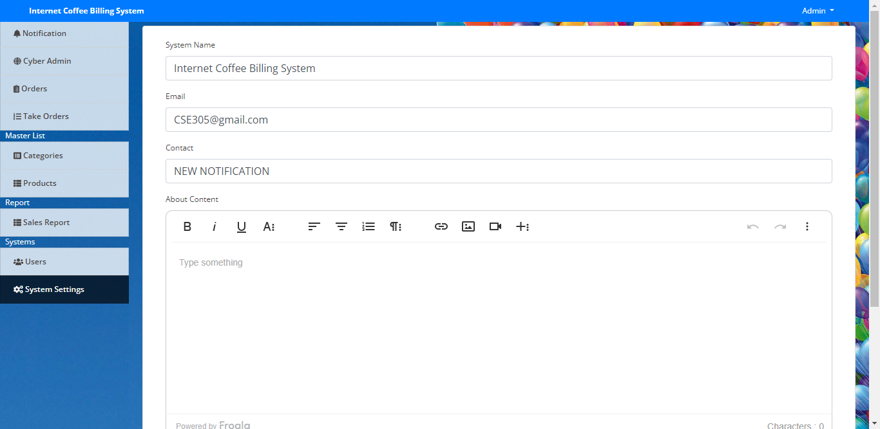System setting helps manage notifications to the homepage or change the system name.

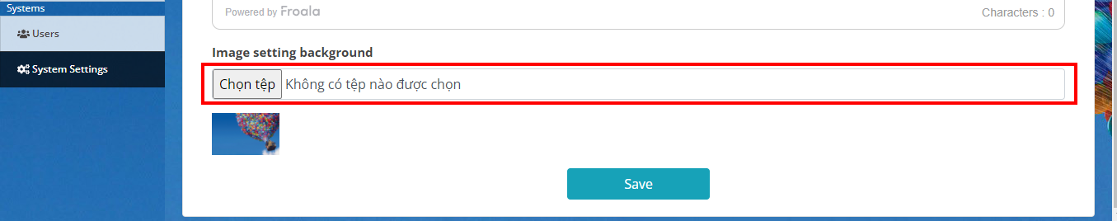In this part , the system has a secondary function , allowing the manager to change the background interface .

## Use Case Model

USE CASE MODEL

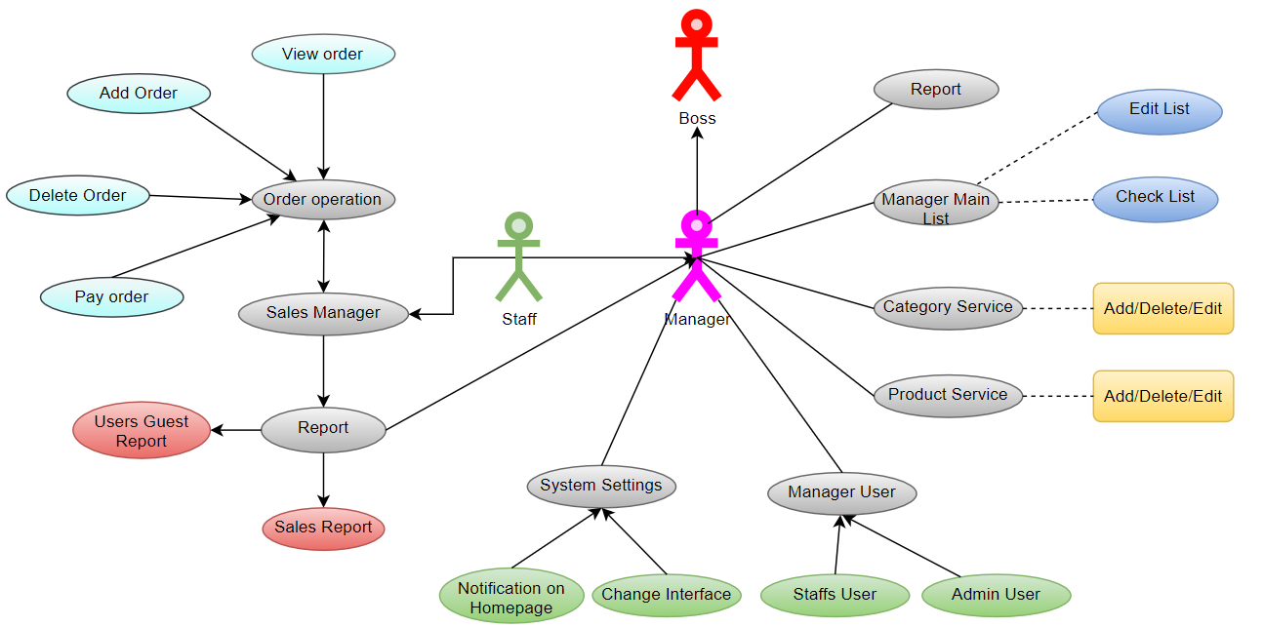

### Use case actor list

|  |  |
| --- | --- |
| **Actor Name** | **Function** |
| Manager | Can perform management operations with everything, region – IP, menu, edit information and view reports |
| Boss | Another type of management actor |
| Staffs | Capable of making orders, providing IP for customers using the internet (making customer orders). |
| Guest | Provided with accounts, computers and equipment of the shop. |

### List of Use Case

|  |  |
| --- | --- |
| **Usecase** | **Function** |
| UC1 Ordering operations |  |
| * UC1.1 Add Food and Sevice | dish Add a dish or drink to the customer's order list. |
| * UC1.2 Setup of Guest Computers | Switches the state of selected computers to Prepared. |
| * UC1.3 Bill Payments | Bill payments to customers. |
| UC2 Working on computers |  |
| * UC2.1 Add a new computer | Add a new computer to the system |
| * UC2.2 Edit and update computer information | Edit computer information and ip computer |
| UC3 User Actions |  |
| * UC3.1 Add User Information | Add New Material Information |
| * UC3.2 Edit User Information | Edit customer information |
| * UC3.3 Search for users | Perform a search for customer information according to given conditions. |
| UC4 Menu Operations |  |
| * UC4.1 Add dish | Add a new food or drink to the served list. |
| * UC4.2 Edit dishes | Edit information related to food and drinks served. |
| UC05 Report | Export reports to users. |

### Use case description

#### Ordering operations

**a. UC1.1 Add Food and Sevice**

**Description:** The function that allows adding dishes to simplify dishes

**Special Description.**

**Pre-conditions:**

• The user has logged into the system with confirmed permissions.

• Order function form, select Add dish.

**Line events:**

• Main event line:

o The user selects the dish from the list of dishes.

o Show Select screen.

o Enter the quantity of the item, the caption is required.

o pay before or pay after

o Display information of dishes in the order list at the ordering screen with the status of not paying and already paid.

• Other event lines:

o If you click "X", the selected dish information will be deleted, returning to the ordering screen.

**Pos-condition:** None

**Open wide:** No

**b. UC1.2 Setup of Guest Computers**

**Description:** The function allows to prepare the computer and space for the user.

**Specific description.**

**Pre-conditions:**

• The user has logged into the system with confirmed permissions.

• Order function screen.

**Event line:**

• Main event line:

o Press the Prepare button.

o Change the status to prepare.

o Check information and save invoice data to the database with invoice status as unpaid.

• Other line of events:

o Report an error if the database has a problem.

**Pos-condition:** None

**Expansion:** None

**c. UC1.3 Bill Payments**

**Description:** The function that allows customers to pay the bill of the respective table is selected.

**Specific description.**

**Pre-conditions:**

• The user has logged into the system with confirmed permissions.

• From the main screen, select the ordering function.

**Event line:**

• Main event line:

o User presses “Payment” button.

o Retrieve related invoices from database and display invoice screen with payment confirmation.

o Press the Pay button.

o Change invoice status in database with paid status.

o Export notifications to users.

• Other line of events:

o Click Cancel, do not make payment

**Pos-condition:** None

**Expanded:** Allows to print the list of dishes to be made to transfer to the Bartender.

#### Working on computers

**a. UC2.1 Add a new computer**

**Description:** This use case allows the administrator to add a new computer to the system.

**Specific description.**

**Pre-conditions:**

• The user must log in to the system and must have Administrator rights.

**Event line:**

• Main event line:

o User selects Computer Management function.

o The system displays a list of the restaurant's desktop computers.

o User selects region.

o The system displays a list of tables in that area.

o User selects IP Address.

o The system requires the administrator to enter information about the table including: Computer Name (*), Computer Locations(*), ID Address(*). Note: Information marked with an asterisk (*) is required information.

o After filling in all necessary information about the table, the system user selects Add.

o The system checks the validity and inconsistencies in the database of information.

o Table information is added in the system.

o Export notifications to users.

o The list of newly updated computers in the dashboard is displayed again on the screen.

• Other event lines:

o Incomplete machine information:

* If the information entered by the system user is incomplete, the system will display an error message: missing necessary information and requesting additional information. System users can add all necessary information or cancel the operation being performed, at this point the use case ends.

o Invalid table information:

* If the information entered by the system user is not valid, the system will display an error message: the information about the desk area is invalid and ask the system user to correct the information. illegal. System users can correct incorrect information or cancel the operation being performed, at which point the usecase ends.

o The validation is not approved by the system user:

* If the confirmation of the respective operations is not approved by the user, the system will revert to the previous state of each respective event stream.

**Post-conditions:**

• If the Use Case is successful, the computer information is added to the system. Otherwise the state of the system does not change.

**Expansion:** None.

**b. UC2.2 Edit and update computer information**

**Description:** The function allows to merge update requests from one computer to another (transfer customer requests.)

**Specific description.**

**Pre-conditions:**

• The user has logged into the system with confirmed permissions.

• From the main screen, select the table switching function.

**Event line:**

• Main event line:

o User selects two computers A and B to transfer (A goes to B).

o Right click and select “update”

o Display confirmation of table transfer from A to B

o You can choose:

o Sub stream:

* Perform the transfer of invoices from table A to table B in the database..
* Select “Do not transfer”, do not perform the conversion.

• Other line of events:

o Notify the user if there is a conversion problem in the database.

**Pos-condition:** None

#### User Actions

**a. UC3.1 Add User Information**

**Description:** This use case allows the administrator to add a new user to the system.

**Specific description.**

**Pre-conditions:**

• The user must log in to the system and must have Administrator rights.

**Event line:**

• Main event line:

o User selects User Management function.

o The system displays the list of users of the restaurant.

o User selects additional address information.

o The system requires the manager to enter information about the area including: User Name (*), User Address(*), Mobile Number(*), Email(*), Computer Name(*), ID Proof(*) . Note: Information marked with an asterisk (*) is required information.

o After filling in all the necessary information, the system user selects Add.

o The system checks the validity and inconsistencies in the database of information.

o Information about is added in the system.

o Export notifications to users.

o The list of newly updated numbers of people and computers is displayed back to the Dashboard.

• Other event lines:

o Information about incomplete:

* If the information entered by the system user is incomplete, the system will display an error message: missing necessary information and requesting additional information. System users can add all necessary information or cancel the operation being performed, at this point the use case ends.

o Invalid desk area information:

* If the information entered by the system user is not valid, the system will display an error message: the information about the desk area is invalid and ask the system user to correct the information. illegal. System users can correct incorrect information or cancel the operation being performed, at which point the use case ends.

o The validation is not approved by the system user:

* If the confirmation of the respective operations is not approved by the user, the system will revert to the previous state of each respective event stream.

**Post-conditions:**

• If the Use Case is successful, the information is added to the system. Otherwise the state of the system does not change.

**Expansion:** None.

**b. UC3.2 Edit User Information**

**Description:** This use case allows the administrator to edit the information of a user in the system.

**Specific description.**

**Pre-conditions:**

• The user must log in to the system and must have Administrator rights.

**Event line:**

• Main event line:

o User selects User Management function.

o The system displays the list of shops.

o User selects want to edit. User selects Update function.

o The system retrieves and displays the selected information.

o The system user changes some of this information. Includes all information indicated in the Add flow.

o After modifying the information, the system user selects Save.

o The system checks the validity of the information.

o Information about is updated back into the system.

o Export notifications to users.

• Other event lines:

o Incomplete site information:

* If the information entered by the system user is incomplete, the system will display an error message: missing necessary information and requesting additional information. System users can add all necessary information or cancel the operation being performed, at this point the use case ends.

o Invalid information:

* If the information entered by the system user is not valid, the system will display an error message: the information about the desk area is invalid and ask the system user to correct the information. illegal. System users can correct incorrect information or cancel the operation being performed, at which point the use case ends.

o The validation is not approved by the system user:

* If the confirmation of the respective operations is not approved by the user, the system will revert to the previous state of each respective event stream.

**Post-conditions:**

• If the Use Case is successful, the desk area information is updated to the system. Otherwise the state of the system does not change.

**Expansion:** None.

**d. UC3.3 Search for users**

**Description:** This Use Case allows the user to search for the user by the ID provided by the System.

**Specific description**.

**Pre-conditions:**

• The user must log in to the system.

**Event line:**

• Main event line:

o User enters the ID to search. Press the search button.

o The system displays a list of Users whose names contain the characters entered and can be checked.

• Other event lines:

**Post-conditions:**

• If the Use Case is successful, a list of matching ingredients will be displayed. Otherwise the state of the system does not change.

**Expansion:** None.

#### Menu Operations

**a. UC4.1 Add dish**

**Description:** This use case allows the administrator to enter new items in the system.

**Specific description.**

**Pre-conditions:**

• The user must log in to the system and must have Administrator rights.

**Event line:**

• Main event line:

o User selects Category and Product function.

o The system displays the list of current items in stock.

o The user selects an item to enter the category. The user selects the Save function.

o The system requires the manager to enter information about raw materials to enter the warehouse, including: Category (*), Name (*), Description and Price(*) . Note: Information marked with an asterisk (*) is required information.

o After filling in all necessary information about the dish, the system user selects Save.

o The system checks the validity and inconsistencies in the database of information.

o Information about incoming materials is stored in the system.

o Export notifications to users.

o The newly updated inventory list is displayed back on the screen.

• Other event lines:

o Incomplete dish information:

* If the information entered by the system user is incomplete, the system will display an error message: missing necessary information and requesting additional information. System users can add all necessary information or cancel the operation being performed, at this point the use case ends.

o Invalid item information:

* If the information entered by the system user is not valid, the system will display an error message: the employee information is invalid and ask the system user to correct the invalid information. Invalid. System users can correct incorrect information or cancel the operation being performed, at which point the use case ends.

o The validation is not approved by the system user:

* If the confirmation of the respective operations is not approved by the user, the system will revert to the previous state of each respective event stream.

**Post-conditions:**

• If the Use Case is successful, the material information is updated into the system. Otherwise the state of the system does not change.

**Expansion:** None.

**b. UC4.2 Edit dishes**

**Description:** This use case allows the administrator to enter new items in the system.

**Specific description.**

**Pre-conditions:**

• The user must log in to the system and must have Administrator rights.

**Event line:**

• Main event line:

o User selects Category and Product functions.

o The system displays the list of current dishes.

o The user selects a material to edit. User selects the Edit function.

o The system retrieves and displays the information of the selected material.

o System users change and delete some information of this dish. Including: Category, Name, Description and Price.

o After modifying the information, the system user selects Save.

o The system checks the validity of the information.

o Information about the dish is updated back into the system.

o Export notifications to users.

• Other event lines:

o Information on raw materials is incomplete:

* If the information entered by the system user is incomplete, the system will display an error message: missing necessary information and requesting additional information. System users can add all necessary information or cancel the operation being performed, at this point the use case ends.

o Invalid material information:

* If the information entered by the system user is not valid, the system will display an error message: the employee information is invalid and ask the system user to correct the invalid information. Invalid. System users can correct incorrect information or cancel the operation being performed, at which point the use case ends.

o The validation is not approved by the system user:

* If the confirmation of the respective operations is not approved by the user, the system will revert to the previous state of each respective event stream.

**Post-conditions:**

• If the Use Case is successful, the material information is updated into the system. Otherwise the state of the system does not change.

**Expansion:** None.

#### Report

**a. UC8.1 Report output**

**Description:** The function allows to render the Report when the user needs it.

**Specific description.**

**Pre-conditions:**

• The user has logged into the system with confirmed permissions.

• From the main screen, select the Report function.

Event line:

• Main event line:

o Enter information for the Report such as weekly, monthly, report time...

o Click the “Report” button

o Check the information you just entered

o Render reports, display to users.

• Other line of events:

o Notify the user if there is a problem while retrieving data from the database.

**Pos-condition:** None

# Other Non-functional Requirements

## Performance Requirements

• The system runs exactly as the project proposed, good and stable.

• Complete interface can change the background at will, easy to use with all .

• Meet most of the user's requirements.

• Report the list of users and the payment are completed as well as the client requested.

## Safety and Security Requirements

Provide decentralization for responsible user types: Manager, Cashier, Admin.

It is completely impossible for a stranger to log into the system, we will build a firewall and security that is safe enough for the client when this application is actually used.

## Software Quality Attributes

### Result

After a semester, the project of Internet Cafe Management System has been basically completed. Through this project, the group learned the business processes in selling coffee shops, understanding the process of analyzing, designing and developing a website-based software. Despite many difficulties, the team tried to complete the assigned schedule and achieved positive results.

### Advantages and Defect

Prioritized:

* Simple software interface, friendly, easy to use.
* Have full professional skills of sales and management of computer users in the cafe.
* There is a document specification program.
* Change notifications, background interface, so you can add and edit easily.

Defect:

* Unfinished in some functions.
* Executable computer has not been tested when put into use.

### Future work

The team will complete the incomplete functions in the future, trying to create a sales management software that is suitable for all coffee shops from small to large. Adding two layers of information security functions to help customers feel secure and best use.

Appendix A – Data Dictionary

**Database Design**

Ccmsdb

**Tbladmin**

|  |  |  |  |  |  |  |
| --- | --- | --- | --- | --- | --- | --- |
| **Column** | **Type** | **Null** | **Default** | **Link to** | **Note** | **Media type** |
| ID *(Primary)* | int(10) | Are not |  |  |  |  |
| AdminName | varchar(120) | Yes | *NULL* |  |  |  |
| UserName | varchar(120) | Yes | *NULL* |  |  |  |
| MobileNumber | bigint(10) | Are not |  |  |  |  |
| Email | varchar(200) | Are not |  |  |  |  |
| Password | varchar(120) | Yes | *NULL* |  |  |  |
| AdminRegdate | timestamp | Yes | current_timestamp() |  |  |  |

**Indexing**

|  |  |  |  |  |  |  |  |  |
| --- | --- | --- | --- | --- | --- | --- | --- | --- |
| **Key name** | **Type** | **Only** | **Packed** | **Column** | **Quantity** | **Coding code table** | **Null** | **Note** |
| PRIMARY | BTREE | Yes | Are not | ID | 4 | A | Are not |  |

**Tblcomputers**

|  |  |  |  |  |  |  |
| --- | --- | --- | --- | --- | --- | --- |
| **Column** | **Type** | **Null** | **Default** | **Link to** | **Note** | **Media type** |
| ID *(Primary)* | int(10) | Are not |  |  |  |  |
| ComputerName | varchar(120) | Yes | *NULL* |  |  |  |
| ComputerLocation | varchar(120) | Yes | *NULL* |  |  |  |
| IPAdd | varchar(120) | Yes | *NULL* |  |  |  |
| EntryDate | timestamp | Yes | current_timestamp() |  |  |  |

**Indexing**

|  |  |  |  |  |  |  |  |  |
| --- | --- | --- | --- | --- | --- | --- | --- | --- |
| **Key name** | **Type** | **Only** | **Packed** | **Column** | **Quantity** | **Coding code table** | **Null** | **Note** |
| PRIMARY | BTREE | Yes | Are not | ID | 8 | A | Are not |  |

**Indexing**

|  |  |  |  |  |  |  |  |  |
| --- | --- | --- | --- | --- | --- | --- | --- | --- |
| **Key name** | **Type** | **Only** | **Packed** | **Column** | **Quantity** | **Coding code table** | **Null** | **Note** |
| PRIMARY | BTREE | Yes | Are not | ID | twelfth | A | Are not |  |

**Blusers**

|  |  |  |  |  |  |  |
| --- | --- | --- | --- | --- | --- | --- |
| **Column** | **Type** | **Null** | **Default** | **Link to** | **Note** | **Media type** |
| ID *(Primary)* | int(10) | Are not |  |  |  |  |
| EntryID | varchar(20) | Yes | *NULL* |  |  |  |
| UserName | varchar(120) | Yes | *NULL* |  |  |  |
| UserAddress | varchar(200) | Yes | *NULL* |  |  |  |
| MobileNumber | bigint(10) | Yes | *NULL* |  |  |  |
| Email | varchar(200) | Yes | *NULL* |  |  |  |
| ComputerName | varchar(120) | Yes | *NULL* |  |  |  |
| IDProof | varchar(120) | Yes | *NULL* |  |  |  |
| InTime | timestamp | Yes | current_timestamp() |  |  |  |
| OutTime | timestamp | Yes | *NULL* |  |  |  |
| Fees | varchar(120) | Yes | *NULL* |  |  |  |
| Remark | varchar(120) | Yes | *NULL* |  |  |  |
| Status | varchar(20) | Are not |  |  |  |  |
| UpdateDate | timestamp | Yes | *NULL* |  |  |  |

cafe_billing_db

**Categories**

|  |  |  |  |  |  |  |
| --- | --- | --- | --- | --- | --- | --- |
| **Column** | **Type** | **Null** | **Default** | **Link to** | **Note** | **Media type** |
| id *(Primary)* | int(30) | Are not |  |  |  |  |
| name | varchar(200) | Are not |  |  |  |  |
| description | text | Are not |  |  |  |  |

**Indexing**

|  |  |  |  |  |  |  |  |  |
| --- | --- | --- | --- | --- | --- | --- | --- | --- |
| **Key name** | **Type** | **Only** | **Packed** | **Column** | **Quantity** | **Coding code table** | **Null** | **Note** |
| PRIMARY | BTREE | Yes | Are not | id | 9 | A | Are not |  |

**Orders**

|  |  |  |  |  |  |  |
| --- | --- | --- | --- | --- | --- | --- |
| **Column** | **Type** | **Null** | **Default** | **Link to** | **Note** | **Media type** |
| id *(Primary)* | int(11) | Are not |  |  |  |  |
| ref_no | varchar(50) | Are not |  |  |  |  |
| total_amount | float | Are not |  |  |  |  |
| amount_tendered | float | Are not |  |  |  |  |
| order_number | int(30) | Are not |  |  |  |  |
| date_created | datetime | Are not | current_timestamp() |  |  |  |

**Indexing**

|  |  |  |  |  |  |  |  |  |
| --- | --- | --- | --- | --- | --- | --- | --- | --- |
| **Key name** | **Type** | **Only** | **Packed** | **Column** | **Quantity** | **Coding code table** | **Null** | **Note** |
| PRIMARY | BTREE | Yes | Are not | id | 13 | A | Are not |  |

**Order_items**

|  |  |  |  |  |  |  |
| --- | --- | --- | --- | --- | --- | --- |
| **Column** | **Type** | **Null** | **Default** | **Link to** | **Note** | **Media type** |
| id *(Primary)* | int(30) | Are not |  |  |  |  |
| order_id | int(30) | Are not |  |  |  |  |
| product_id | int(30) | Are not |  |  |  |  |
| qty | int(30) | Are not |  |  |  |  |
| price | float | Are not |  |  |  |  |
| amount | float | Are not |  |  |  |  |

**Indexing**

|  |  |  |  |  |  |  |  |  |
| --- | --- | --- | --- | --- | --- | --- | --- | --- |
| **Key name** | **Type** | **Only** | **Packed** | **Column** | **Quantity** | **Coding code table** | **Null** | **Note** |
| PRIMARY | BTREE | Yes | Are not | id | 37 | A | Are not |  |

**Oroducts**

|  |  |  |  |  |  |  |
| --- | --- | --- | --- | --- | --- | --- |
| **Column** | **Type** | **Null** | **Default** | **Link to** | **Note** | **Media type** |
| id *(Primary)* | int(30) | Are not |  |  |  |  |
| category_id | int(30) | Are not |  |  |  |  |
| name | varchar(200) | Are not |  |  |  |  |
| description | text | Are not |  |  |  |  |
| price | float | Are not |  |  |  |  |
| status | tinyint(1) | Are not | first |  | 0=Unavailable,1=Available |  |

**Indexing**

|  |  |  |  |  |  |  |  |  |
| --- | --- | --- | --- | --- | --- | --- | --- | --- |
| **Key name** | **Type** | **Only** | **Packed** | **Column** | **Quantity** | **Coding code table** | **Null** | **Note** |
| PRIMARY | BTREE | Yes | Are not | id | 25 | A | Are not |  |

**system_settings**

|  |  |  |  |  |  |  |
| --- | --- | --- | --- | --- | --- | --- |
| **Column** | **Type** | **Null** | **Default** | **Link to** | **Note** | **Media type** |
| id *(Primary)* | int(30) | Are not |  |  |  |  |
| name | text | Are not |  |  |  |  |
| email | varchar(200) | Are not |  |  |  |  |
| contact | varchar(20) | Are not |  |  |  |  |
| cover_img | text | Are not |  |  |  |  |
| about_content | text | Are not |  |  |  |  |

**Indexing**

|  |  |  |  |  |  |  |  |  |
| --- | --- | --- | --- | --- | --- | --- | --- | --- |
| **Key name** | **Type** | **Only** | **Packed** | **Column** | **Quantity** | **Coding code table** | **Null** | **Note** |
| PRIMARY | BTREE | Yes | Are not | id | 0 | A | Are not |  |

**users**

|  |  |  |  |  |  |  |  |  |  |  |
| --- | --- | --- | --- | --- | --- | --- | --- | --- | --- | --- |
| **Column** | **Type** | **Null** | **Default** | | **Link to** | | **Note** | | **Media type** | |
| id *(Primary)* | int(30) | Are not | |  | |  | |  | |  |
| name | text | Are not | |  | |  | |  | |  |
| username | varchar(200) | Are not | |  | |  | |  | |  |
| password | text | Are not | |  | |  | |  | |  |
| type | tinyint(1) | Are not | | 3 | |  | | 1=Admin,2=Staff | |  |

**Indexing**

|  |  |  |  |  |  |  |  |  |
| --- | --- | --- | --- | --- | --- | --- | --- | --- |
| **Key name** | **Type** | **Only** | **Packed** | **Column** | **Quantity** | **Coding code table** | **Null** | **Note** |
| PRIMARY | BTREE | Yes | Are not | id | 3 | A | Are not |  |

**Appendix B - Group Log**

**OVERVIEW**

Group 5: We started building the topic website in October. But things didn't go well, so we decided to change the topic to Internet Cafe Management System. As a matter of fact, our group has studied web programming, object-oriented programming and is studying databases. Especially now, the software engineering subject in charge of Ms. Shreya Banerjee has helped us to complete this project in the most complete way, accumulating a lot of experience while studying. In this project, our team divided the work into three parts:

* Design the entire web interface using HTML/CSS:
* Nguyen Minh Man
* Database design for website using MySQL/phpMyAdmin:
* Nguyen Tien Dat
* Software design and overall website using PHP/AJAX/JQUERY/JAVASCRIPT:
* Nguyen Trung Hieu
* Nguyen Xuan Doanh

This system is developed in PHP language with MySQL as backend. The system is a menu driven one. User-friendly menus will help both the administrator and the clients to work on it without any operational difficulty.

All code for the website will be attached to this project report, there are two files:

* The file name to be compressed is named CSE305_Project_Team5.zip
* Database: cafe_billing_db.sql and ccmsdb.sql compressed with the name Database.zip

This is Github Repository : "https://github.com/hieu131196/CSE-305.git" of us project, where my team have uploaded all source code.